Press Release
14-April-2024
VIKRAM SAHNEY ORGANIZES BAISAKHI MARATHON IN CAPITAL
BAISAKHI MARATHON ON SAY NO TO DRUGS
In a spirited celebration of health and vitality, the capital city witnessed a remarkable event as S. Iqbal Singh Lalpura, Chairman of the National Commission of Minorities, flagged off the Vaisakhi 5K Run in Delhi alongside 113-year-old Marathon Runner Fauja Singh, popularly known as Turban Tornado, under the aegis of Dr. Vikramjit Singh Sahney, Padma Shri awardee. Dedicated to the theme of "Say No to Drugs," the marathon served as a rallying call to motivate youth towards a healthy lifestyle and away from substance abuse.
The marathon, organized under the banner of the World Punjabi Organisation Vaisakhi 5K Run, saw over 3000 enthusiastic participants take to the streets of Delhi, all united in the cause of promoting a drug-free lifestyle. The event was graced by the presence of numerous dignitaries from the World Punjabi Organisation, adding to the fervor of the occasion.
In a significant announcement, Dr. Vikramjit Sahney unveiled two empowering schemes aimed at Punjab's youth in the Banking, Finance, and Insurance (BFSI) and Aviation sectors. Through partnerships with IFM Fincoach and Frankfinn Institute, the schemes will facilitate pre-job offers with free training and scholarships for aspiring professionals, respectively. The initiatives, under the banner of Sun Foundation, underscore the commitment to equipping youth with the skills for a brighter future.
The vibrant atmosphere of the run was underscored by the presence of Turbanator Bikers leading the saffron-turbaned runners, symbolizing unity and strength in the face of adversity. With the resounding slogan "Har Maidan Fateh," participants marched towards victory against drug abuse.
The run concluded on a high note, with colorful Bhangra performances and spirited displays of Sikh Martial Art Gatka, underscoring the celebration of culture and resilience.
For media inquiries, please contact: 9910061111
Follow us on Twitter: @vikramsahney
Visit our website: www.sunfoundationindia.org
About WPO and Sun Foundation -
Established in 1998 under the esteemed patronage of former Prime Minister Sh. IK Gujral, the World Punjabi Organization is a global entity with chapters spanning over 20 countries. Complementing this noble endeavour, the SUN Foundation, established in the same year, has been tirelessly working towards the uplift and empowerment for the underprivileged, through various social welfare initiatives towards free skilling and job placement assistance for youth, Drug de-addiction and rehabilitation and rescue and rehabilitation after repatriation of Punjabis across border to name a few.

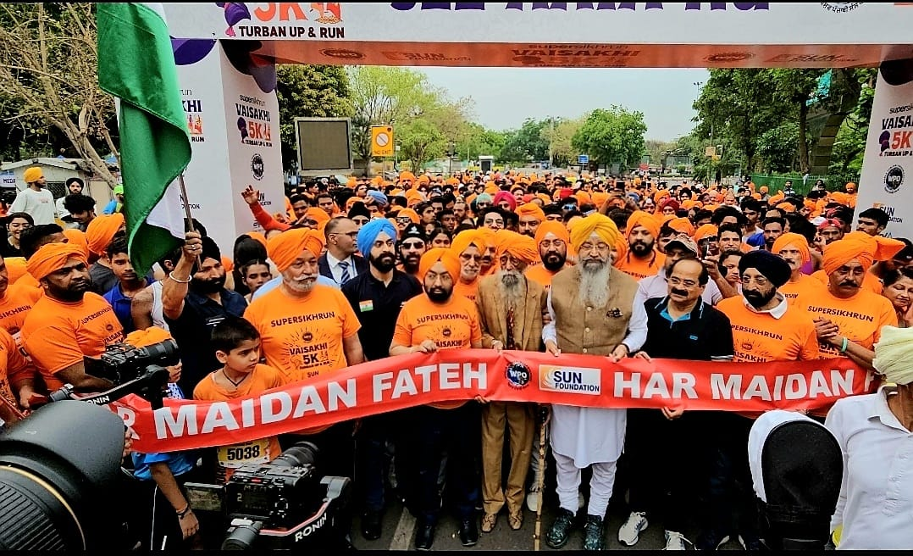

In the Attached Picture: Iqbal Singh Lalpura, Chairman, Minority Commission, Turban Tornado Fauja Singh and MP Vikram Sahney leading the Vaisakhi Marathon in New Delhi

